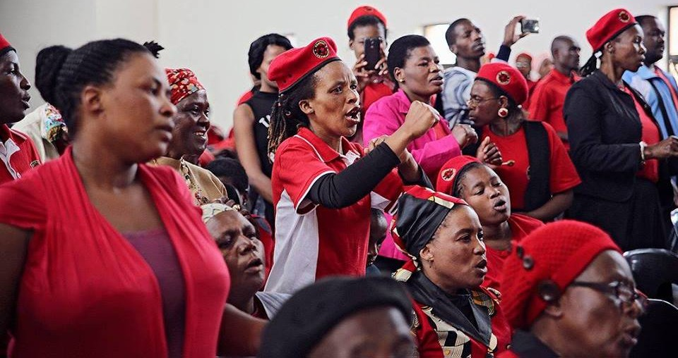

Lindokuhle Mnguni has been assassinated
20 August 2022
Abahlali baseMjondolo press statement
Lindokuhle Mnguni has been assassinated
In the early hours of this morning Lindokuhle Mnguni, the chairperson of the eKhenana Commune and the Youth League, was assassinated at the Commune.
Mnguni was a powerful intellectual with a mind like a razor. He was a young man with real vision and commitment, a brave man whose will to struggle was not broken by six months in prison, long periods in hiding and having to bury two close comrades this year. He was already interested in radical ideas while in high school and he read Biko, Fanon, Malcom X and Marx. Mnguni ran a reading group in prison with books such as The Wretched of the Earth and Pedagogy of the Oppressed and various pamphlets that we were able to smuggle into the prison at his request. He was a communist and an internationalist. Meetings at the Commune always started with the Internationale. The Communist Manifesto was studied line by line in the Frantz Fanon school along with writers like Fanon and Freire. Even while living under constant threat Lindokuhle was in solidarity with the struggle against the monarchy in Swaziland. In fact he led a delegation to Swaziland when PUDEMO lost a comrade.
Mnguni’s vision and commitment was central to the achievements of the Commune including the struggle to occupy and hold the land, the model of democratic self-organisation developed in the Commune, its militant commitment to oppose patriarchy, the successful urban farming projects, the collectively managed shop and kitchen, the creche, the poetry project and, of course, the Frantz Fanon School, which attracted militants from around the country and beyond. It was his vision that the school would become a place of learning and building solidarity for the international left. The next step in his vision was to build accommodation for visitors to the school.
The land on which the eKhenena Commune was developed was first occupied in 2018. From there democratic self-organisation was developed from below, confronting many challenges along the way including repeated illegal and violent attempts by the municipality to crush the Commune and intimidation and violence from local ANC structures. The Commune then developed all kinds of collective projects including the successful food sovereignty project, started with seeds donated by the MST in Brazil.
The Commune faced severe repression. There were regular arrests and periods of imprisonment on fake charges, people’s homes were burnt and there were two assassinations. Ayanda Ngila, another leader of the Commune who spent six months in prison with Mnguni on bogus charges, was assassinated on 8 March. Nokuthula Mabasao was assassinated on 5 May. Mnguni knew that he had chosen to live and struggle in the shadow of death. He made it very clear, in his calm and gentle way, that he had chosen socialism or death. This is how he gave meaning to his life in a world of oppression that gave no value to his life, and how he enriched all of our lives.
Mnguni was a brilliant young man with a great future in leadership. He was a fearless leader and stood for his community. He was always humble yet strong. He always dedicated his time to the people. Mnguni was well known on the left and in Pan Africanist circles. He believed that we are the Biko of today, that we must understand that we are on our own and stand up for ourselves and our humanity. His passion for the people of eKhenana showed when he spoke. We lost a real cadre of the left, of the movement of the people, of the real struggles of the oppressed.
This assassination comes at a time when the movement is facing serious repression from the Local ANC in ward 101, Cato Manor. At the same time there is new development – night time raids on occupations by extremely violent masked police officers. One person has already been killed in these raids.
Mnguni is 24th leader of our movement who has died at the hands of the police and the izinkabi hired by the ruling party. We have no doubts that the killers of Mnguni are the same killers of Ngila and Mabaso.
We are in mourning. Our hearts are heavy. We have lost a real leader with a very bright future. We have lost someone who was prepared to lay down his life for the Commune, the movement and the struggle for a world where land, wealth and power are shared and the humanity of all is recognised. He has been in and out of prison as a result of fighting for the people of eKhenana. He was a selfless leader who believed that we must fight without compromise against capitalism, imperialism, racism and the thieves and thugs in the ANC.
A lion has fallen.
We have no trust in the police.
This morning when the sun came up the garden in the eKhenena Commune was green. The chickens were thriving. And once again the residents were devastated, standing in small groups and talking quietly.
They need maximum solidarity. We need maximum solidarity. The residents need to know that they are not alone as they face the possibility of death and the destruction of all that they have worked for.
We are Mnguni and we are socialists. We will continue the struggle.
We sing the Internationale because it is a song for the world and we are internationalists who take our place in the world as comrades among other comrades. But from today we will also sing the Internationale for Mnguni. It is a song for the world, it is our song and it is also his song.
Hamba kahle qhawe lamaqhawe
Uyibekile induku ebandla
Thapelo Mohapi 084 576 5117
S’bu Zikode: 083 5470 474
Mqapheli Bonono 073 067 3274

