Bedouin home demolished near Ramallah
Today (Last Update) Time 11:32
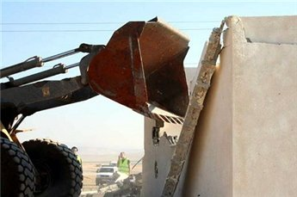
[MaanImages]
Bethlehem – Ma’an – Israeli bulldozers, accompanied by the Israeli army, demolished the home of Hassan Salem Al-Ka’abna in the village of Jab’a, southeast of Ramallah on Tuesday.
According to Salem Al-Ka’abna, Hassan’s son, the family had not received formal notification of the demolition. The home was demolished because the roof is constructed out of aluminum, which requires an Israeli planning permit.
Israeli forces initially prohibited the family from collecting their belongings, but were eventually swayed and allowed the women to retrieve certain items, the son said, adding that soldiers handcuffed him and his cousin Nidal Moussa until the demolition was complete.
Ten members of the Al-Ka’bna family were made homeless as a result, including five infants.
The family home was built in 1978, before the nearby Adam settlement was constructed, which is 200 meters from the home. In 1994, the family added a balcony to the home.
Local Bedouin near the Jab’a village expressed concern for their future, as many have received official demolition warnings.
The Al-Ka’bnas are a Bedouin family originally from the south. After 1948, they settled in Yatta south of Hebron and then in Ramallah in the mid 70s.
Continued displacement of the Bedouin
During her final speech in Sheikh Jarrah in December , former Commissioner General of UNRWA Karen AbuZayd took the opportunity to speak of the ongoing displacement of the Bedouin across the West Bank. "On International Human Right day, I would also like to highlight the plight of one of the most disadvantaged groups in this region, the bedouins of the West Bank."
"As the occupying power, Israel remains responsible for ensuring that the basic needs of the occupied population are met. But many refugee Bedouin and herding communities, originally displaced from their traditional lands in 1948, are now experiencing multiple counts of displacement from area C as they are forcibly moved from their homes."
"These groups are now sinking deeper into food insecurity and abject poverty, as grazing land continues to shrink and access to natural resources is severely restricted by the occupying power. Administrative demolition, forced evictions, collapsing livelihoods, poverty and settler harassment represent the key triggers to displacement for area C herding communities today and they're already stretched coping mechanism are now reaching their limits. They're full rights must be respected as a matter of utmost urgency."
Source: http://www.maannews.net/eng/ViewDetails.aspx?ID=255345

